~~The Halifax Agricultural Society~~
www.halifaxshow.org.uk
74th Halifax Show
Saturday 13th August 2022
Savile Park, Halifax, HX3 0HG
CPH: 49/349/8001

Sheep Schedule
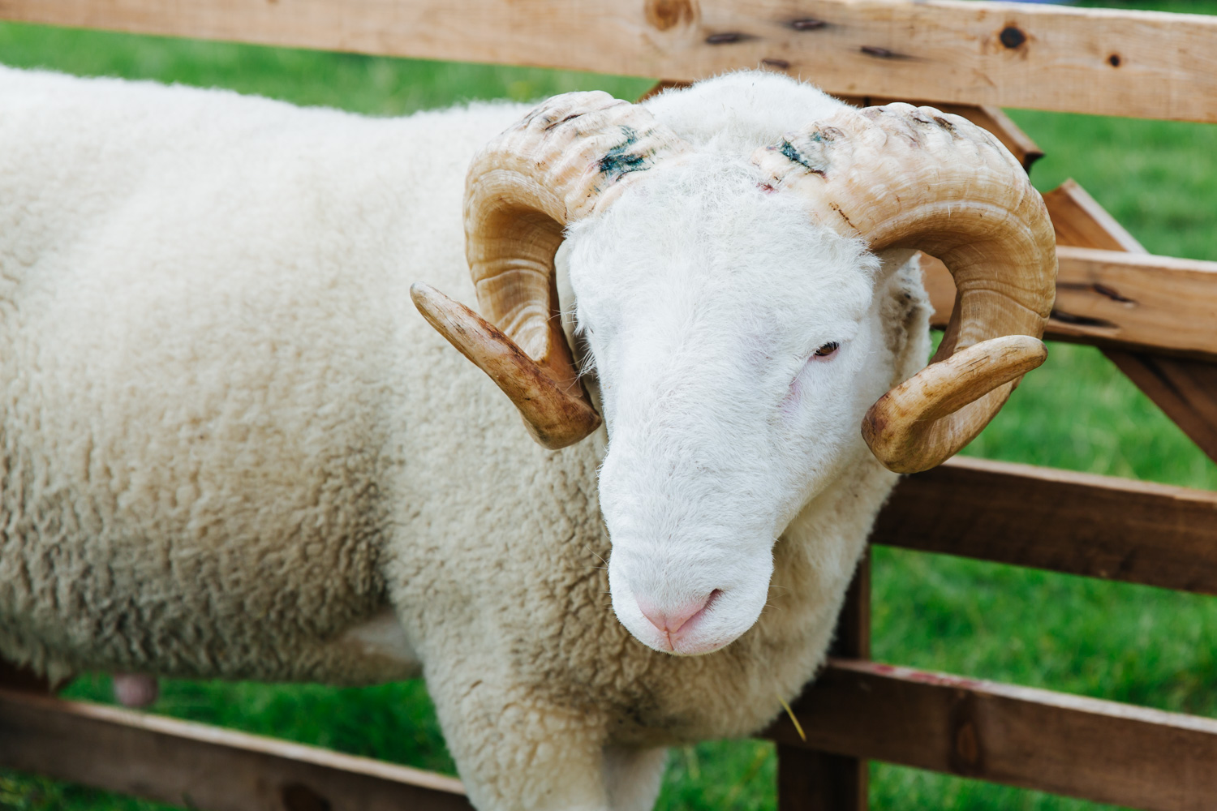

All enquiries for this section to:
Mrs Elizabeth Greenwood, 110 Unity Terrace, Oldham Road, Ripponden, Halifax
HX6 4DP
Contact Lizzie on 01422 825324 or 07796552352 or email at
e.greenwood324@btinternet.com
~~~Closing Date: 31st July 2022~~~

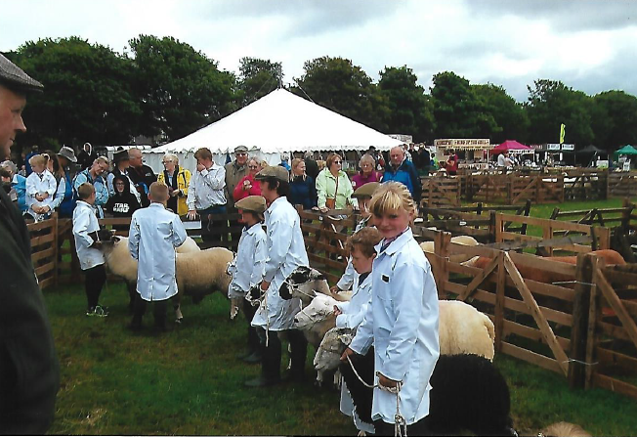

Key Rules and Undertakings
All sheep and lambs must be tagged with UK flock number and individually.

- All exhibitors must have Public Liability Insurance.
- No entry will be accepted unless it is on an official form and accompanied by the correct fee.
- The Judge’s decision will be final.
- Sheep are the responsibility of their owner and the Society cannot be held responsible for loss, damage or injury to sheep, property or vehicles.
- There must be competition in all classes and The Society reserves the right to Create or Amalgamate classes depending on entries, and restrict the prize money in the event of insufficient entries.
- Sheep must by penned by 9.00am and must be kept on the show ground until 5.00pm.
- Please state on entry form if sheep are accredited.
- It is recommended that all sheep brought to the show ground be protected from sheep scab.
- The Society reserve the right to refuse entry of any sheep showing indications of any contagious disease.
- Sheep in Fat Lamb and Young Handler classes cannot be shown in any other class.
- ENTRIES: Must be sent on the enclosed form and returned to the Sheep Section Secretary with a cheque, made payable to The Halifax Agricultural Society Ltd.

Further Information

- Entry Fee: £2.00 per entry.
- Entries close 31st July 2022 (late entries - £1 extra per sheep)
- Prize money will be allocated as follows:
1st - £8, 2nd - £5, 3rd - £3, Rosette for 4th
- Prize money for Young Handler classes will be allocated as follows:
1st - £5, 2nd - £4, 3rd - £3, 4th - £2, ‘Well Done’ Rosette for 5th, 6th etc.
- One bag of corn for each 1st in classes 1 to 3 kindly donated by Stephenson‛s Animal feed. Each child receives a bag of sweets.

Halifax Agricultural Society - Sheep Section

Welome back to the Sheep section after a 2 year break. I hope you have all kept well and have had a good lambing time and hay making. As you will no doubt remember 2019 was a total washout with the weather and we thank everyone who made the effort and turned out to support the show.
I would also just like to take a moment to mention my late father-in-law John Greewood who we sadly lost last August. John has been a great support to me as Sheep Secretary since I took on the role in 2003 and he was very proud of what I have achieved over the years with the section. He is greatly missed.
Lets hope for a warm, sunny day for 2022 and I look forward to seeing you then.
I look forward to seeing regular and new exhibitors at the 202 show.
NOTE: ALTHOUGH TROPHIES ARE LISTED IN THE SCHEDULE, FOR THIS YEAR ONLY, NO TROPHIES WILL BE AWARDED AS WE WILL BE CARRYING OUT INVENTORY, REPAIR, RE-PURPOSE, VALUATION, THEY WILL BE GIVEN OUT AS NORMAL FOR 2023 SHOW.

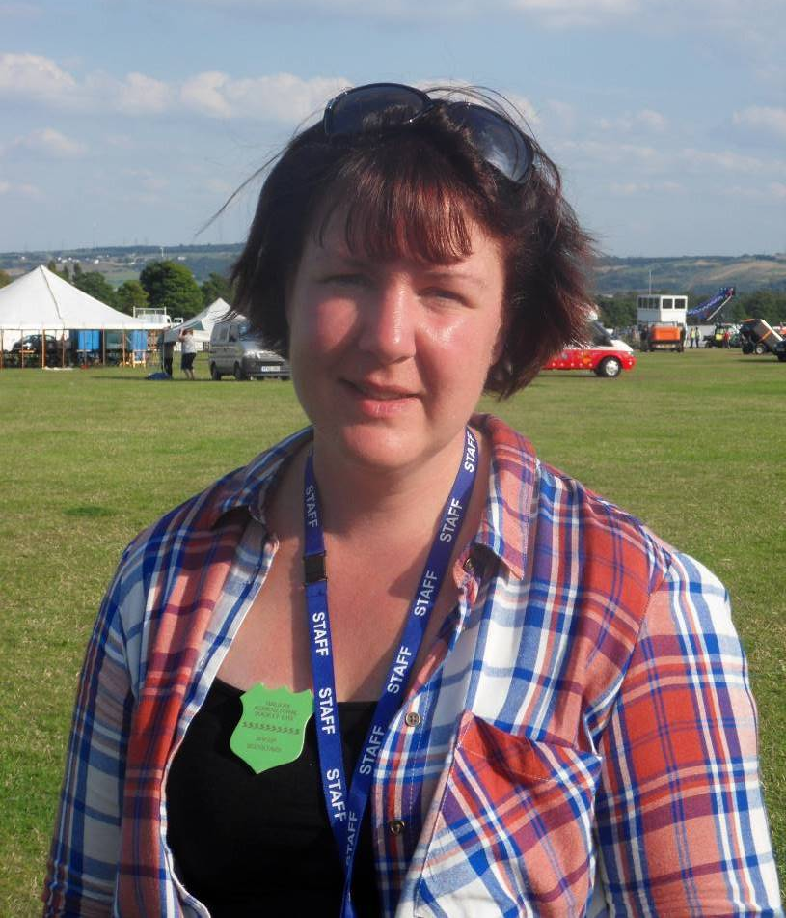
Lizzie Greenwood
Sheep Section Secretary

Classes

YOUNG HANDLER

Judge: TBC To be judged at 10.00am

Class 1 - Aged 2 to 6 years old - Mary Elizabeth Greenwood trophy.
Class 2 - Aged 7 to 11 years old – Eleanor May Greenwood trophy.
Class 3 - Aged 12 to 16 years old – George William Greenwood trophy.

Each child will receive a bag of sweets and a rosette.

DERBYSHIRE GRITSTONE

Judge: TBC To be judged at 10.30am

The Lloyds Bank trophy will be awarded to the Champion Derbyshire Gritstone.
Champion and Reserve Champion Rosettes kindly donated by Derbyshire Gritstone Sheep Breeders Society.
~Please note this is a qualifier for the CHAMPION OF CHAMPIONS to be held on Bank Holiday Monday 29th August at Hope Show. Champion when qualified to contact Mrs Jane Needham (Hope Show) 07973796510.~

Class 4 - Ram, 2 Shear or over.
Class 5 - Shearling Ram – Allan Greenwood trophy.
Class 6 - Ram Lamb.
Class 7 - Ewe, to have reared a lamb in 2022.
Class 8 - Shearling Ewe – Allan Greenwood trophy.
Class 9 - Ewe Lamb.
Class 10 - Group of three. One male and two females irrespective of age.

LONK

Judge: TBC To be judged at 11.30am approx.

J Hey trophy will be awarded to the Champion Lonk.
Edward Stott shield to be awarded to aged tup.

Champion and Reserve Champion Rosettes kindly donated by Lonk Sheep Breeders Society.

Class 11 - Ram, 2 Shear or over.
Class 12 - Shearling Ram.
Class 13 - Ram Lamb.
Class 14 - Ewe, to have reared a lamb in 2022.
Class 15 - Shearling Ewe.
Class 16 - Ewe Lamb.
Class 17 - Group of three. One male and two females irrespective of age.

HAMPSHIRE DOWN

Stephen Short trophy will be awarded to the Champion Hampshire Down.

Judge: TBC To be judged at 11.30am approx.

Class 18 - Ram, 2 Shear or over.
Class 19 - Shearling Ram.
Class 20 - Ram Lamb.
Class 21 - Ewe, to have reared a lamb in 2022.
Class 22 - Shearling Ewe.
Class 23 - Ewe Lamb.
Class 24 - Group of three. One male and two females irrespective of age.

RYELAND

Judge: TBC To be judged at 10.30am approx.

H Holdsworth will be awarded to the Champion Ryeland.

Class 25 - Ram, 2 Shear or over.
Class 26 - Shearling Ram.
Class 27 - Ram Lamb.
Class 28 - Ewe, to have reared a lamb in 2022.
Class 29 - Shearling Ewe.
Class 30 - Ewe Lamb.
Class 31 - Group of three. One male and two females irrespective of age.

COLOURED RYELAND

Judge: TBC To be judged at 11.30am approx.

Coloured Ryeland trophy will be awarded to the Champion Coloured Ryeland.

Class 32 - Ram, 2 Shear or over.
Class 33 - Shearling Ram.
Class 34 - Ram Lamb.
Class 35 - Ewe, to have reared a lamb in 2022.
Class 36 - Shearling Ewe.
Class 37 - Ewe Lamb.
Class 38 - Group of three. One male and two females irrespective of age.

ANY OTHER PURE BRED OR CONTINENTAL BREED

Judge: TBC To be judged at 12.00pm approx.

Jack Eccles trophy to be awarded to the Champion Any Other Pure Bred or Continental Breed.

Class 39 - Ram, 2 Shear or over.
Class 40 - Shearling Ram.
Class 41 - Ram Lamb.
Class 42 - Ewe, to have reared a lamb in 2022.
Class 43 - Shearling Ewe.
Class 44 - Ewe Lamb.
Class 45 - Group of three. One male and two females irrespective of age.

WHITEFACED WOODLAND

Judge: TBC To Be Judged at 12.30pm.

Ken Wild cup will be awarded to the Champion Whitefaced Woodland.
Haydon Thorp trophy will be awarded to the Champion Home Bred Shearling Ram.

Class 46 - Ram, 2 Shear or over.
Class 47 - Shearling Ram.
Class 48 - Ram Lamb.
Class 49 – Ewe, to have reared a lamb in 2022.
Class 50 - Shearling Ewe.
Class 51 - Ewe Lamb.
Class 52 - Group of three. One male and two females irrespective of age.

FAT LAMBS

Judge: TBC To be judged at 11.00am approx.

Mallinsons trophy to be awarded to the Champion Pen of Fat Lambs.
Douglas Fairbank trophy to be awarded to the 2nd Pen of Fat Lambs.
Raymond Eccles trophy will be awarded to the Best Lamb in Show.

Class 53 - Two fat lambs suitable for the present day trade.

~N.B - lambs in this class are not eligible for any other class.~

Show Supreme Champion

~~TO FOLLOW ON FROM JUDGING~~

Eric Douglas Barrett trophy will be awarded to the Show Supreme Champion.

Mary Barrett trophy will be awarded to the Champion Young Handler.

Supreme Champion at 3.00pm
Best Lamb and presentation of awards

Sponsors

The Society would like to offer thanks to all who sponsor the Sheep Section. Your continued support is very much appreciated!

- Stephenson’s Animal Feeds (Todmorden) for two bags of corn for the Supreme Champion, three 25kg bags and ten sample bags of corn in the Young Handler section.
- Calvag Agricultural Supplies (Mytholmroyd)
- Derbyshire Gritstone Sheep Breeders Association
- Lonk Sheep Breeders Association
- Whitefaced Woodland Sheep Breeders Association
- Ryeland Sheep Association
- Coloured Ryeland Association
- Millhouse world of wood ( Rishworth)

Sadly due to the lack of exhibitors The Texel Class has been cancelled, any exhibits of Texels please enter in Any Other Pure Bred Breed.

In memory of John Pickard of Great Harwood

