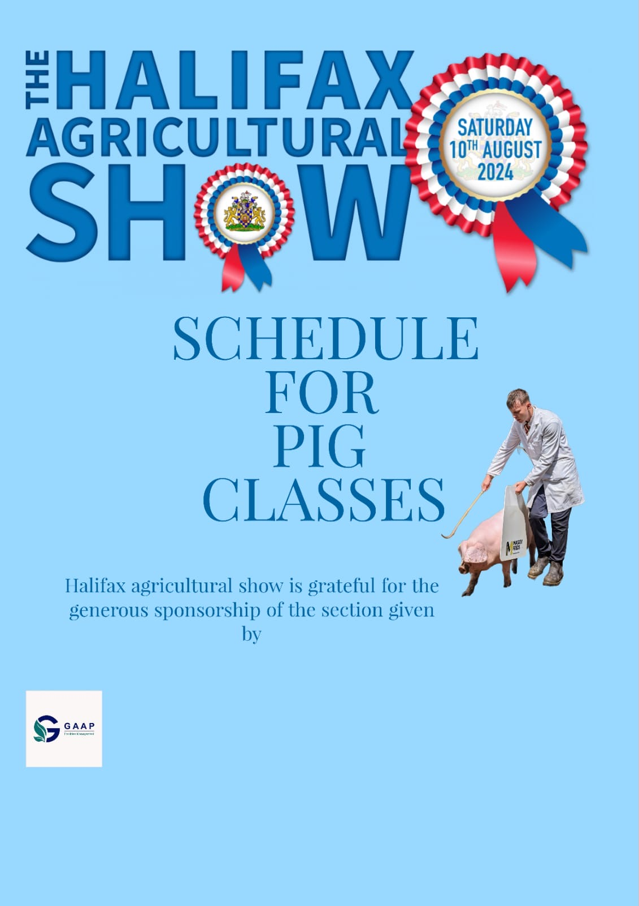
Bio-Security
Summer livestock shows are in full swing again across the country. For all livestock exhibitors whether you are new to the show ring or returning after a two-year absence, biosecurity measures are extremely important as they are the first line of defence to preventing disease entering your farm and herd.
Listed below are some key biosecurity practices to reduce the risk of spreading diseases.
Before the Show
Work alongside your vet to implement a preventative health programme to ensure that all vaccinations are up to date
Keep show animals penned separately so that they can be quarantined before and after being away for a show
Ensure all equipment (buckets, boards and sticks, brushes etc.) are clean
Avoid travelling alongside other stock especially where the health status of the animals is unknown. If travelling with another farm is unavoidable keep animals separate in the trailer
Take the feed that the animals are accustomed to
At the Show Biosecurity Tips to Keep your Livestock Show Animals Healthy
Keep your distance and avoid nose to nose contact with other animals at the show
Keep your equipment, hands and footwear clean to avoid spreading bacteria
Avoid sharing feed, brushes, water and equipment etc. with other exhibitors
Know the signs of disease and observe show animals when returning from shows
Keep unused feed covered to avoid the risk of contamination
Avoid standing in manure. Disinfect your shoes. Do not take manure home on your feet
After the Show
Dispose of leftover bedding, hay and feed which you may have taken back from the show with you
Ensure that all equipment and clothing and the livestock trailer is properly washed and disinfected
Keep show stock isolated from other stock for a minimum of 21 days ideally 30 days
Avoid cross contamination with other stock on the farm and show animals which may be in isolation
Carefully monitor show animals for any signs of illness or disease

Exhibitors are requested to take note of the following.
Exhibitors must enter the Showground ONLY through the labelled Pig livestock gate.
Times of admission - because of the necessity to man gates, exhibitors must bring their
stock to the Show during the following times: -
Friday 9th August- between 5.00pm and 10.00pm
Saturday 10th August - from 6.00 am to 8.00 am
Livestock Vehicles - Exhibitor vehicles used to transport livestock must be externally clean.
The Society reserves the right to refuse entry to any vehicle deemed not to be clean.
Footwear & Clothing - Animal handlers must wear suitable protective clothing and footwear
capable of being cleaned and disinfected.
The key message is 'be clean and be seen to be clean'
EXHIBITORS' RESPONSIBILITIES
Exhibitors are responsible for the care of their stock and for any damage or loss caused by their animals whilst on the Showground. Exhibitors are reminded that they are solely responsible for, and in charge of, their stock at all times during the event.
ENTRIES CLOSE on 5th July 2024. All entries and payments must be completed on the paper entry form. For people who need assistant with this contact Gavin Pawson (Pig Secretary) on 07376488722
HOW TO MAKE YOUR ENTRY
1 Complete the paper entry form and send via email to pigs@halifaxshow.uk or post to Gavin Pawson, 30 Broadway, Partington, Manchester, M31 4DH
2 Entry fees can be paid by cheque to Halifax Agricultural Society Limited or a Bank Transfer to: Halifax Agricultural Society Limited Sort Code: 60-09-27 Account Number: 83804900 Reference Pigs and surname.
3 Pens - Please indicate on your entry form how many pens you require
4 Please provide as much information as possible. If animal registration numbers are requested to comply with class requirements, then they must be listed.
5 Entry Fees are £7, whilst pen fees are free.
Prize Money
Prize money will be issued in cash on the day of the show.
REGULATIONS
AN ELECTRONIC ANIMAL MOVEMENT LICENCE (eAML2) issued under the Pigs
(Records, Identification and Movement) Order 2011 must accompany all pigs.
1. Pigs to have been registered in a published volume or accepted for entry in a forthcoming
volume of the British Pig Association's Herd Book or the British Lop Pig Society's Herd
Book.
2. The ear number, registered name, Herd Book number and date of birth of each pig, also
the Name and Herd Book number of the sire and dam must be supplied for printing in
the catalogue, together with the name of the breeder in cases where the exhibitor is not
also, the breeder.
FAILURE TO SUPPLY FULL INFORMATION WILL RESULT IN YOUR ENTRY BEING
RETURNED.
3. At all Shows in 2024, female pigs (all breeds) born before 1 January 2024 shall be eligible
to compete only if in the six calendar months prior to the Show they have farrowed,
suckled and reared to four weeks of age, a birth notified litter of pigs.
4. At all Shows in 2024, female pigs born on or after 1st January and before 1st July in the
year before the show must within 18 months of their date of birth have farrowed, suckled
and reared to four weeks of age, a birth notified litter of pigs.
5. All boars must be shown by two competent (over 16yrs of age) handlers who are equipped with
protective boards. Anyone deemed not competent by the judge may be asked to leave the ring.
6. The use of artificial colouring, whitening and/or powder on pigs as well as the removal or
addition of spots by artificial means is prohibited (white wood flour is permitted)
7 Exhibitors can arrive on Friday or before 8.00 am on Saturday and not leave before 5.00 pm Saturday.
8 Halifax Agricultural Show can offer both free camping and parking in the vicinity of the pig section for exhibitors, plus other facilities. (*if wishing to camp please make a note on entry form)
SECTION SECRETARY
G PAWSON Email: pigs@halifaxshow.uk
Mobile: 07376488722
HOLDING NUMBER: 49/349/8001
General
Closing date: | Friday 5th July 2024

JUDGE: Mr R S Bowers
Rosettes to 5th place
ENTRY FEES £7.00 per entry (including Pairs class) plus admin fee (shown at the end of the application)
PENNING FEE FREE
2 exhibitor wristbands will be given per pig.
With thanks to our sponsors / supporters: TBC

Judging will commence at 9am
Pigs to be penned by 8am, pigs arriving after this time will be refused entry
Pigs must not leave until the end of the show.
Water and bedding will be on offer
Pens only available strictly for pigs. No kit pens to be booked. There will be a separate area for exhibitors and their equipment. Number of pens required (pigs only) to be included on entry form.
No boars to be exhibited in young handler or Fancy Dress
Classes may be split depending on breed types and numbers entered as Halifax Agricultural Show’s discretion.

Pig Classes
Modern Breed Classes
PRIZE MONEY 1st - £40 2nd - £20 3rd - £10
- 1 – Sow any age
- 2 – July gilt, born 1/7/23 – 31/12/23
- 3 – January gilt, born after 1/1/24
- 4 – Boar born after 1/1/24
- 5 – Best modern pig in show (judged from winners of classes 1-4) Champion £40 Reserve Champion £30
Traditional Breed Classes
PRIZE MONEY 1st - £40 2nd - £20 3rd - £10
- 6 – Sow any age
- 7 – July gilt, born 1/7/23 – 31/12/23
- 8 – January gilt, born after 1/1/24
- 9 – Boar born after 1/1/24
- 10 -Best traditional pig in show (judged from winners of classes 6-9) Champion £40 Reserve Champion £30
Mixed Classes
PRIZE MONEY 1st - £40 2nd - £20 3rd - £10
- 11 – Matching Pair- This may be split into Modern and Traditional depending on entries

Halifax Youth Pig Pageantry £3.50 entry fee
PRIZE MONEY 1st - £20 2nd - £10 3rd - £5
- 12 – Young Handler – aged 4 years and under
- 13 – Young Handler – aged 5-8 years
- 14 – Young Handler – aged 9-12 years
- 15 – Young Handler – aged 13-16 years
- 16 – Young Handler – aged 17-21 years
Championship Classes
- 17 – Best Young Handler Championship (winners of classes 12 - 16 qualify)
Champion Show Bundle of a personalised water proof coat, white coat and show board
Reserve Champion white coat and show board
18 – Best pig in show (Champion and Reserve Champion from classes 5 and 10 qualify)
Champion Pig in Show prize £175
Reserve Champion Pig in Show prize £75

Novelty Classes-
- 19 – Best Fancy Dress (pig and handler) – free to enter- Prize for the winner
- 20- One handler and their pig obstacle course- free to enter- Prize for the winner

