~~The Halifax Agricultural Society~~
http://halifaxshow.uk
76th Halifax Show
Saturday 10th August 2024
Saville Park, Halifax, HX3 0HG
CPH: 49/349/8001

Sheep Schedule
2023 Show Supreme Champion and Champion of Champions
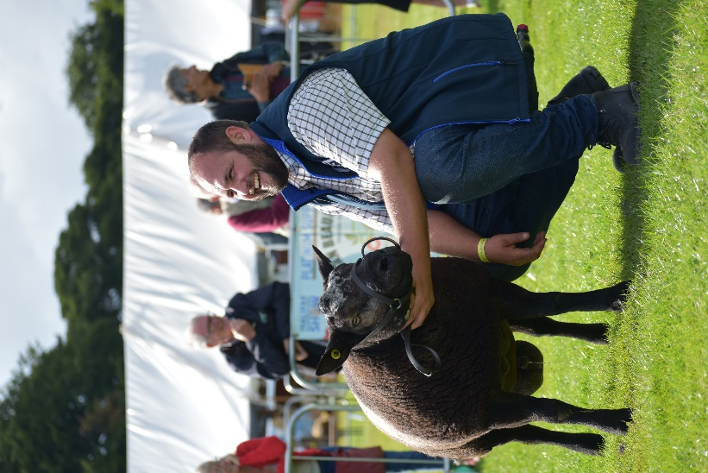

Mr Taylor with his Blue Texel shearling ram

All enquiries for this section to:
Mrs. Elizabeth Greenwood (Lizzie)
Contact Lizzie on 07796552352.
Or: 01422 825324
Email at: sheep@halifaxshow.uk

Entries close on 31st July 2024.
Late entries accepted at £1 extra per Sheep.

Key Rules and Undertakings
All sheep and lambs must be tagged with UK flock number and individually.
- All exhibitors must have Public Liability Insurance.
- No entry will be accepted unless it is on an official form and accompanied by the correct fee.
- The Judge’s decision is final.
- Sheep are the responsibility of their owner, and the Society cannot be held responsible for loss, damage or injury to sheep, property, or vehicles.
- There must be competition in all classes and The Society reserves the right to Create and Amalgamate classes depending on entries and restrict the prize money in the event of insufficient entries.
- Sheep must be penned by 9.00am and must be kept on the show ground until 5.00pm.
- Please state on entry form if sheep are accredited.
- It is recommended that all sheep brought to the show ground be protected from sheep scab.
- The Society reserve the right to refuse entry of any sheep showing indications of any contagious disease.
- Sheep in Fat Lamb and Young Handler classes cannot be shown in any other class.
- ENTRIES: Must be sent on the enclosed form and returned to the Sheep Section Secretary with a cheque, made payable to The Halifax Agricultural Society Ltd.

FURTHER INFORMATION
- Entry Fee: £2.50 per entry.
- Entries close 31st July 2024 (late entries - £1 extra per sheep.
- Prize money will be allocated as follows: 1st - £8, 2nd - £5, 3rd - £3, Rosette for 4th.
- Prize money for Young Handler classes will be allocated as follows: 1st - £5, 2nd - £4, 3rd - £3, 4th - £2, ‘Well Done’ Rosette for 5th, 6th etc.
- One bag of corn for each 1st in classes 1 to 3 kindly donated by Stephenson’s Animal Feed. Each child receives a bag of sweets.
- Sadly, due to the lack of exhibitors the Texel class has been cancelled, any exhibits of Texels please enter in Any Other Pure Breed.

Halifax Agricultural Society - Sheep Section
Hi all, this year will mark my 21st year of being involved with Halifax Show, not bad to say I thought it would be fun and something to do whilst on maternity leave with my first child all those years ago, two children later & I’m still here ha, ha, ha.
Thank you to all who turned out in 2023 for what was a blustery day, but reasonably dry and warm..

Thank you to Calderdale Young Farmers Club for their help in putting the pens up and for staying behind to dismantle them.

Thank you to all who exhibited last year, your support is very much appreciated, and I would like to welcome any new exhibitors to the team.

Elizabeth Greenwood
Sheep Secretary

Secretary’s report 2023

Once again, what a fantastic day, we had 38 exhibitors with 239 sheep entered across 67 classes.
We welcomed 2 new breed classes - Suffolks and Blue Texel which brought in 5 new exhibitors with Mr Taylor winning ‘Supreme Champion’ with his Blue Texel shearling Ram, then going on to win the ‘Champion. of Champions’ in the main ring.

Young Handlers once again had a fantastic turn out and is always a good attraction with 19 children participating across 3 age groups. Miss Hannah Scott did a great job.
I was very honoured to present Steph Challoner with the ‘Young Handler Champion Cup’ which I donated to mark my 20th show .
A list of last year’s trophy winners is at the end of this schedule.

Sheep Classes

Young Handler
Judge:
To be judged at 10:00am
Class 1: Aged 2 to 6 years old – Mary Elizabeth Greenwood Trophy
Class 2: Aged 7 to 11 years old – Eleanor May Greenwood Trophy
Class 3: Aged 12 to 16 years old – George William Greenwood Trophy
Each child will receive a bag of sweets and a rosette.

Derbyshire Gritstone
Judge:
To be judged at 10:30am
The Lloyds Bank trophy will be awarded to the Champion Derbyshire Gritstone.
Champion and Reserve Champion Rosettes kindly donated by Derbyshire Gritstone Sheep Breeders Society.
~Please note this is a qualifier for the CHAMPION OF CHAMPIONS to be held on Bank Holiday Monday 26th August at Hope Show. Champion when qualified to contact Mrs Jane Needham (Hope Show) 07973 796510
Class 4: Ram, 2 Shear or over.
Class 5: Shearling Ram – Allan Greenwood Trophy
Class 6: Ram Lamb
Class 7: Ewe, to have reared a lamb in 2024.
Class 8: Shearling Ewe – Allan Greenwood Trophy
Class 9: Ewe Lamb
Class 10: Group of three : One male and two females irrespective of age

Lonk
Judge:
To be judged at 11:30am approx.
J Hey trophy will be awarded to the Champion Lonk.
Edward Stott shield to be awarded to aged tup.
Champion and Reserve Champion Rosettes kindly donated by Lonk Sheep Breeders Society.
Class 11: Ram, 2 Shear or over.
Class 12: Shearling Ram
Class 13: Ram Lamb
Class 14: Ewe, to have reared a lamb in 2024.
Class 15: Shearling Ewe
Class 16: Ewe Lamb
Class 17: Group of three – One male and two females irrespective of age

Hampshire Down

Judge:

To be judged at approx.
Stephen Short trophy will be awarded to the Champion Hampshire Down.
Class 18: Ram, 2 Shear or over.
Class 19: Shearling Ram
Class 20: Ram Lamb
Class 21: Ewe, to have reared a lamb in 2024.
Class 22: Shearling Ewe
Class 23: Ewe Lamb
Class 24: Group of three – One male and two females irrespective of age

Ryeland
Judge:
To be judged at 10:30am approx.
H Holdsworth Trophy will be awarded to the Champion Ryeland.
Class 25: Ram, 2 Shear or over.
Class 26: Shearling Ram
Class 27: Ram Lamb
Class 28: Ewe, to have reared a lamb in 2024.
Class 29: Shearling Ewe
Class 30: Ewe Lamb
Class 31: Group of three – One male and two females irrespective of age

Coloured Ryeland
Judge:
To be judged at 11:30am approx.
Coloured Ryeland Trophy will be awarded to the Champion Coloured Ryeland.
Class 32: Ram, 2 Shear or over.
Class 33: Shearling Ram
Class 34: Ram Lamb
Class 35: Ewe, to have reared a lamb in 2024.
Class 36: Shearling Ewe
Class 37: Ewe Lamb
Class 38: Group of three – One male and two females irrespective of age

Any other Pure Bred or Continental Breed
Judge:
To be judged at 12:00pm approx.
Jack Eccles trophy to be awarded to the Champion Any Other Pure Bred or Continental Breed.
Class 39: Ram, 2 Shear or over.
Class 40: Shearling Ram
Class 41: Ram Lamb
Class 42: Ewe, to have reared a lamb in 2024.
Class 43: Shearling Ewe
Class 44: Ewe Lamb
Class 45: Group of three – One male and two females irrespective of age

Whitefaced Woodland
Judge:
To be judged at 12:30pm approx.
Ken Wild cup will be awarded to the Champion Whitefaced Woodland.
Haydon Thorp trophy will be awarded to the Champion Home Bred Shearling Ram.
Class 46: Ram, 2 Shear or over.
Class 47: Shearling Ram
Class 48: Ram Lamb
Class 49: Ewe, to have reared a lamb in 2024.
Class 50: Shearling Ewe
Class 51: Ewe Lamb
Class 52: Group of three – One male and two females irrespective of age

Blue Texel
Judge:
To be judged at approx.
Class 53: Ram, 2 Shear or over.
Class 54: Shearling Ram
Class 55: Ram Lamb
Class 56: Ewe, to have reared a lamb in 2024.
Class 57: Shearling Ewe
Class 58: Ewe Lamb
Class 59: Group of three – One male and two females irrespective of age

Suffolk
Judge:
To be judged at approx.
Class 60: Ram, 2 Shear or over.
Class 61: Shearling Ram
Class 62: Ram Lamb
Class 63: Ewe, to have reared a lamb in 2024.
Class 64: Shearling Ewe
Class 65: Ewe Lamb
Class 66: Group of three – One male and two females irrespective of age

Fat Lambs
Judge:
To be judged at 11:00am approx.
Mallinsons trophy to be awarded to the Champion Pen of Fat Lambs.
Douglas Fairbank trophy to be awarded to the 2nd Pen of Fat Lambs.
Raymond Eccles trophy will be awarded to the Best Lamb in Show.
Class 67: Two fat lambs suitable for present day trade

**NB – Lambs in this class are not eligible for any other class**

Show Supreme Champion
**TO FOLLOW ON FROM JUDGING**
Eric Douglas Barrett trophy will be awarded to the Show Supreme Champion.
Mary Barrett trophy will be awarded to the Champion Young Handler.
Supreme Champion at 3.00pm
Best Lamb and presentation of awards

Halifax Show 2023 Trophy winners:

Horace Turner Challenge Trophy for Champion of Champions – S R Taylor
E D Barrett trophy for Supreme Champion – S R Taylor

M E Greenwood trophy for Young Handler 2 – 6 years old – Ted Lund
E M Greenwood trophy for Young Handler 7 – 11 years old – Eddie Battye
G W Greenwood trophy for Young Handler 12 – 16 years old – Seph Challoner
Elizabeth Greenwood Young handler champion – Seph Challoner

Lloyds Bank trophy for Champion Gritstone – Clive Mitchell
Allan Greenwood trophy for Gritstone shearling ram – Joe Mitchell
Allan Greenwood trophy for Gritstone shearling ewe – Joe Mitchell

J Hey trophy for Champion Lonk – Clive Mitchell
Edward Stott Shield for Aged Lonk ram - Clive Mitchell

H Holdsworth trophy for Champion Ryeland – P Gray
Eric Bateman Rosebowl for Ryeland lamb – P Gray
Greave Trophy for 3 White Ryelands – P Gray

Coloured Ryeland trophy for Coloured Ryeland Champion – D Aindow

J Eccles trophy for AOB Champion – S & J Hobson

Ken wild trophy for Whitefaced Woodland Champion – A Crampton
Hayden Thorpe Shield for Shearling Woodland ram - A Crampton

Maidenstones trophy for Blue Texel Champion – Stephen Taylor

R & K Crossley trophy for Suffolk Champion – K Crossley

Mallinson trophy for Fat Lamb – C Kaye

R Eccles trophy for Best Lamb in Show – K Bachelor

